Realizar o login,

Utilizar a biblioteca o Angular –ouath2

<https://github.com/oauthjs/angular-oauth2>

Vamos instalar via bower

bower install angular-oauth2

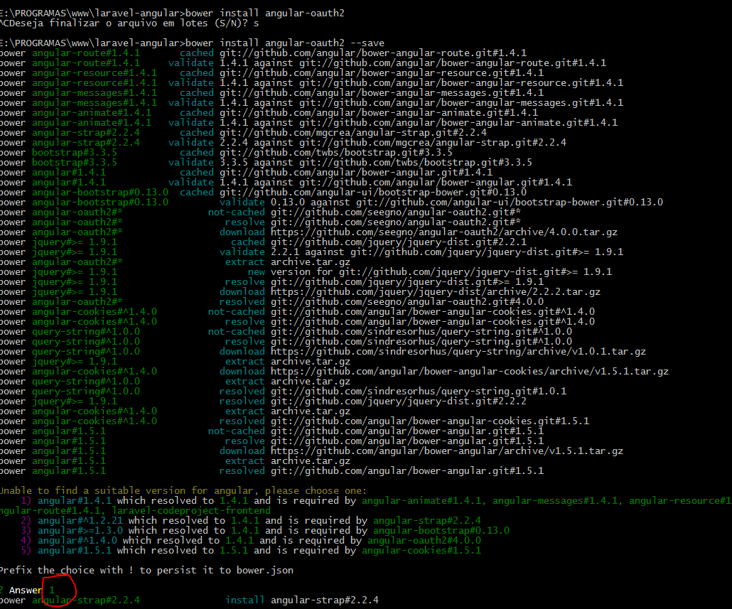

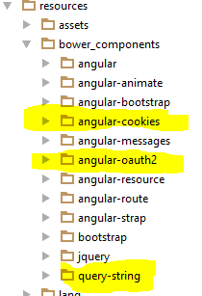

Gulpfile.js no BOWER JS

config.**bower_path** = config.**assets_path** + **'/../bower_components'**;  
  
config.**build_path_js** = config.**build_path** + **'/js'**;  
config.**build_vendor_path_js** = config.**build_path_js** + **'/vendor'**;  
config.**vendor_path_js** = [  
 config.**bower_path** + **'/jquery/dist/jquery.min.js'**,  
 config.**bower_path** + **'/bootstrap/dist/js/bootstrap.min.js'**,  
 config.**bower_path** + **'/angular/angular.min.js'**,  
 config.**bower_path** + **'/angular-route/angular-route.min.js'**,  
 config.**bower_path** + **'/angular-resource/angular-resource.min.js'**,  
 config.**bower_path** + **'/angular-animate/angular-animate.min.js'**,  
 config.**bower_path** + **'/angular-messages/angular-messages.min.js'**,  
 config.**bower_path** + **'/angular-bootstrap/ui-bootstrap.min.js'**,  
 config.**bower_path** + **'/angular-strap/dist/modules/navbar.min.js'**,  
 config.**bower_path** + **'/angular-cookies/angular-cookies.min.js'**,  
 config.**bower_path** + **'/query-string/query-string.js'**,  
 config.**bower_path** + **'/angular-oauth2/dist/angular-oauth2.min.js'**,  
];

Scripts de App.Blade

*<!-- Scripts -->***@if(**Config::*get*(**'app.debug'**)**)** <**script src="**{{ asset(**'build/js/vendor/jquery.min.js'**) }}**"**></**script**>  
 <**script src="**{{ asset(**'build/js/vendor/angular.min.js'**) }}**"**></**script**>  
 <**script src="**{{ asset(**'build/js/vendor/angular-route.min.js'**) }}**"**></**script**>  
 <**script src="**{{ asset(**'build/js/vendor/angular-resource.min.js'**) }}**"**></**script**>  
 <**script src="**{{ asset(**'build/js/vendor/angular-animate.min.js'**) }}**"**></**script**>  
 <**script src="**{{ asset(**'build/js/vendor/angular-messages.min.js'**) }}**"**></**script**>  
 <**script src="**{{ asset(**'build/js/vendor/ui-bootstrap.min.js'**) }}**"**></**script**>  
 <**script src="**{{ asset(**'build/js/vendor/navbar.min.js'**) }}**"**></**script**>  
 <**script src="**{{ asset(**'build/js/vendor/angular-cookies.min.js'**) }}**"**></**script**>  
 <**script src="**{{ asset(**'build/js/vendor/query-string.js'**) }}**"**></**script**>  
 <**script src="**{{ asset(**'build/js/vendor/angular-oauth2.min.js'**) }}**"**></**script**>  
  
 <**script src="**{{ asset(**'build/js/app.js'**) }}**"**></**script**>  
 <**script src="**{{ asset(**'build/js/controllers/login.js'**) }}**"**></**script**>  
 <**script src="**{{ asset(**'build/js/controllers/home.js'**) }}**"**></**script**>  
**@else** <**script src="**{{ elixir(**'js/all.js'**) }}**"**></**script**>  
**@endif**

Gulp watch-dev

Gulp